1. write YOURSELF a basic sorting algorithm.
If you can add one of the merge sort, quick sort and heap sort. but rather one bad that you wrote yourself.
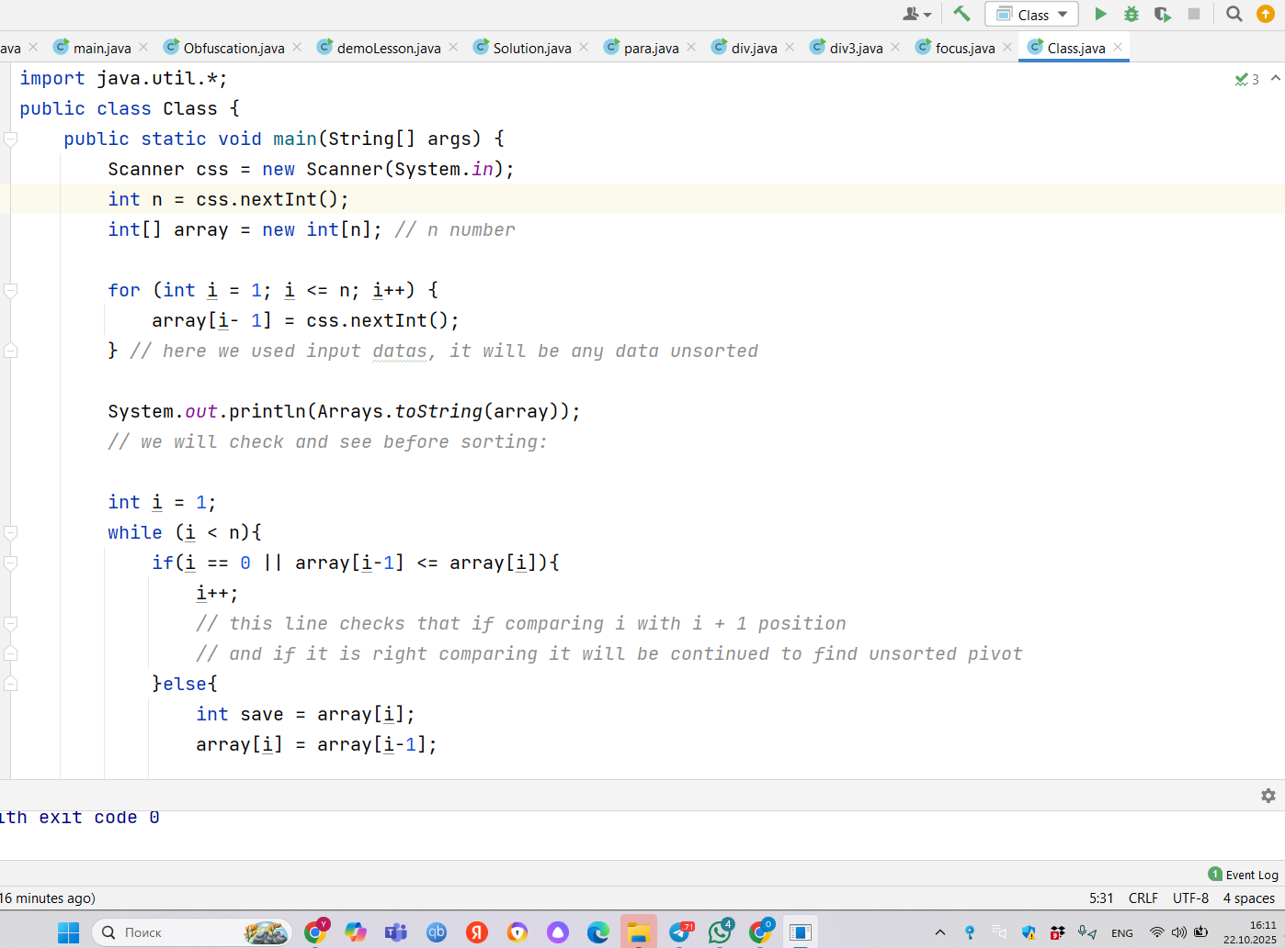
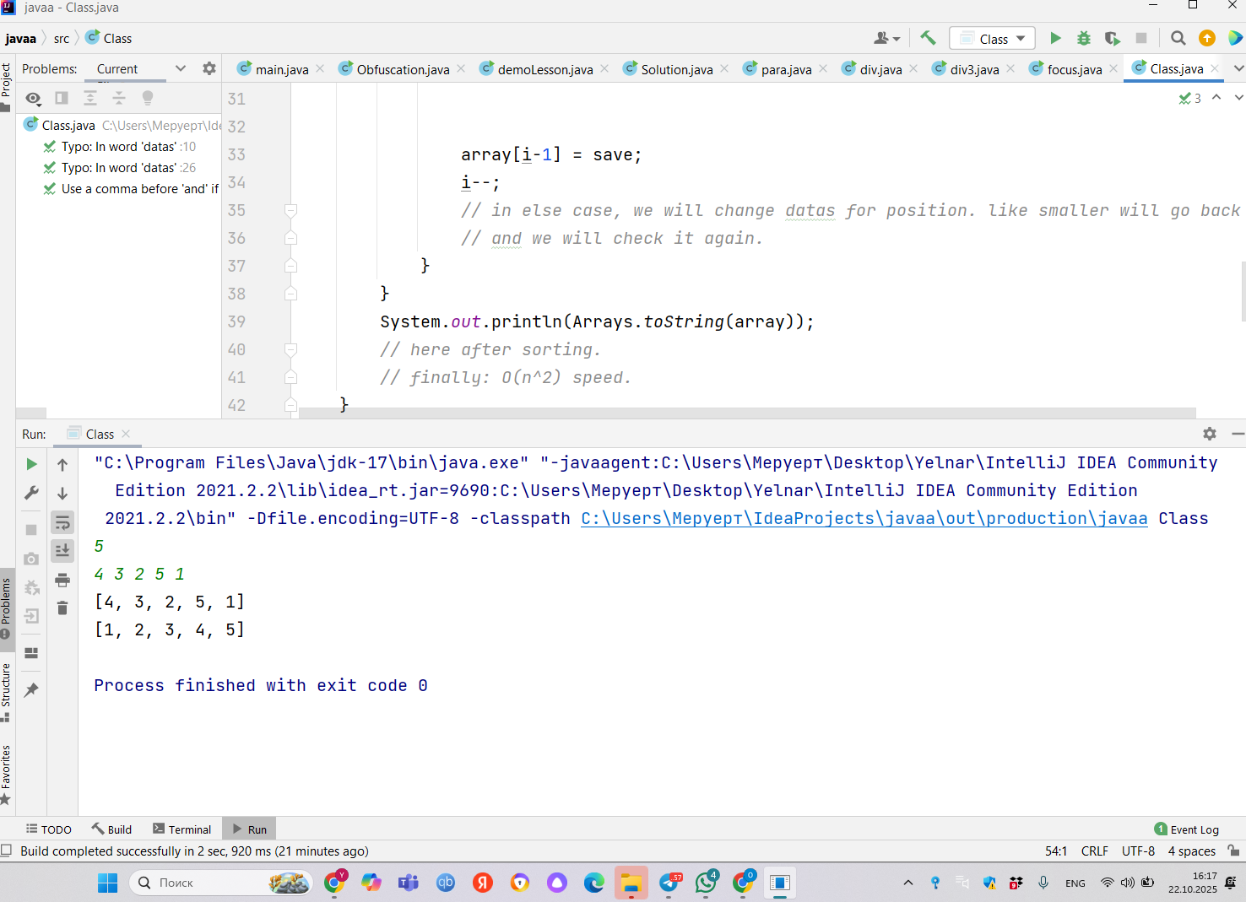
2. add few test cases: show that your algo work on few cases. For instance compare against sorting utility

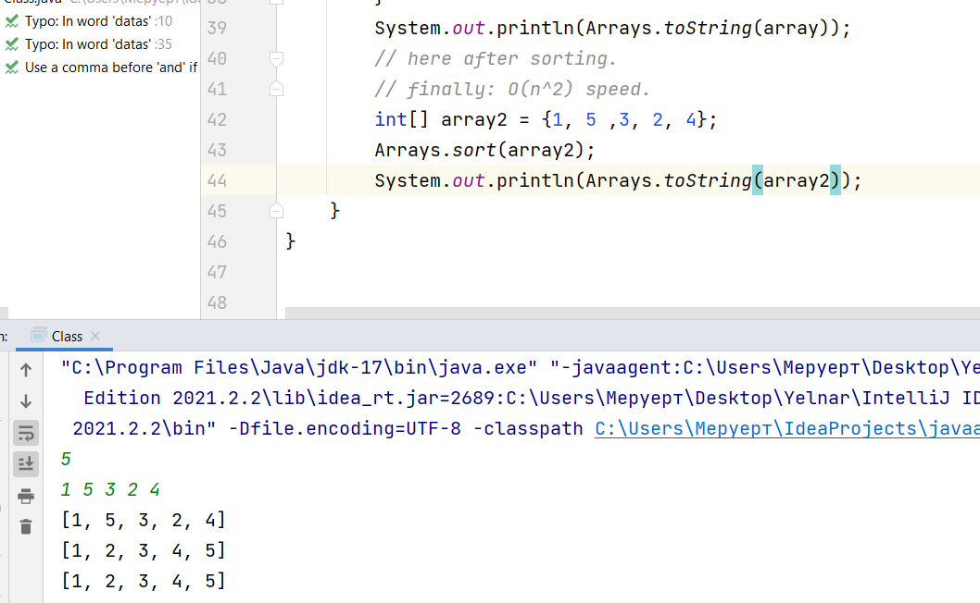
here i compared sorting utility. for utility i wrote data and gave same data for input. they are same and my code also works.

3. analysis: write analysis in big O and explain how you apply master theorem and to which problem. You can ask a colleague because you need to be super quick.
About analysis, i think in best case it will be: O(n) like one going forward, like ideal case.
for worst case: it takes O(n^2) must move back.
Space complexity: O(1)
I asked about master theorem from GPT, it is about takes parts and will manage this part. like quicksort. I think i cannot apply master theorem for my code. because it is iterative like goes by cycle(like loop{while, for} ) i mean not recursive. but if we compare it merge sort. mine is slower. (O(n^2)) vs O(n log n)

import java.util.*;
public class Class {
public static void main(String[] args) {
Scanner css = new Scanner(System.in);
int n = css.nextInt();
int[] array = new int[n]; // n number

for (int i = 1; i <= n; i++) {
array[i- 1] = css.nextInt();
} // here we used input datas, it will be any data unsorted

System.out.println(Arrays.toString(array));
// we will check and see before sorting:

int i = 1;
while (i < n){
if(i == 0 || array[i-1] <= array[i]){
i++;
// this line checks that if comparing i with i + 1 position
// and if it is right comparing it will be continued to find unsorted pivot
}else{
int save = array[i];
array[i] = array[i-1];
array[i-1] = save;
i--;
// in else case, we will change datas for position. like smaller will go back
// and we will check it again.
}
}
System.out.println(Arrays.toString(array));
// here after sorting.
// finally: O(n^2) speed.
int[] array2 = {1, 5 ,3, 2, 4};
Arrays.sort(array2);
System.out.println(Arrays.toString(array2));
}
}

Input: 5
1 5 3 2 4
Output:
[1, 5, 3, 2, 4]
[1, 2, 3, 4, 5]
[1, 2, 3, 4, 5]

